Creating a Rubric in Illuminate

From the Illuminate homepage, either click on the Create Flexible Assessment tile  or  click on the Assessment button at the top left and choose Create Assessment. | 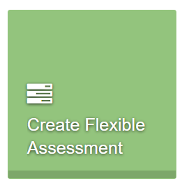
Create a title for your rubric using your school’s naming convention. | 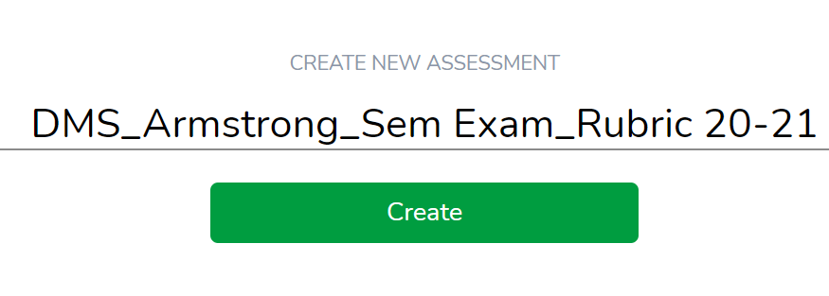
Add the number of questions/indicators you need for your rubric by clicking on the +Add Another button.  All questions default to multiple choice. You can click on the dropdown arrow to change the type of question.  When finished, click on the blue Add # button at the bottom right. | 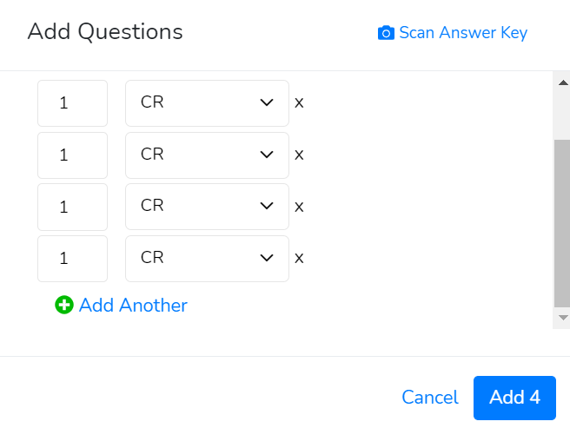
Click on the Standards button to add the standards for this assessment. | 
Any previously used standards will appear at the far right. Click the X to remove them if not needed for this assessment. | 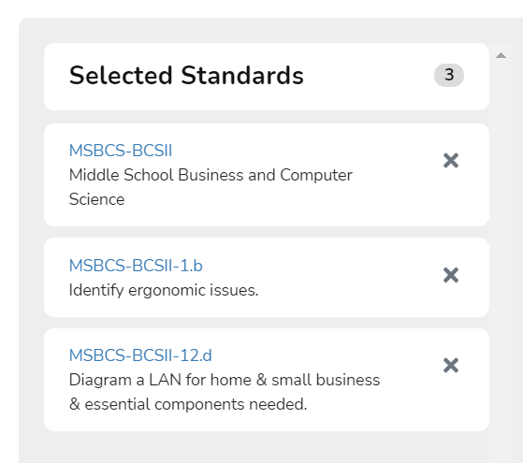
To select standards for this assessment, click on the Providers button (choose CTAE and/or Standards of Excellence under the Georgia heading), then click on the Subjects button (choose the subject(s) for this assessment, and then click on the grade level button (choose the grades for this assessment).  The standards will populate below those buttons.  Click on the gray checkmark to select the standards for this assessment. | 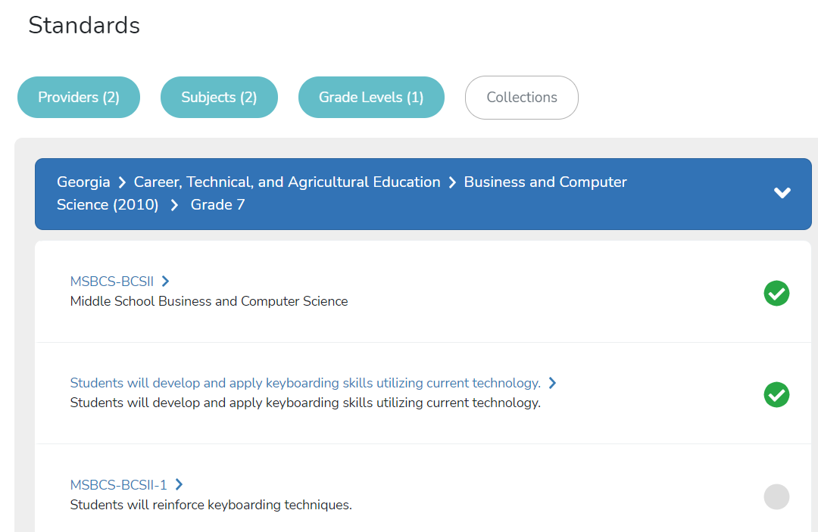
When finished, click the X at the top right of the screen. | 
If you want to rename the label, click in the box and type in what you want. | 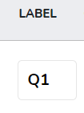
If you want to change the question type, click on the dropdown and select a new question type. | 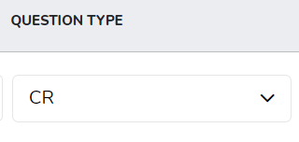
If you want to change the rubric scale, click on the dropdown and choose Edit Choices. | 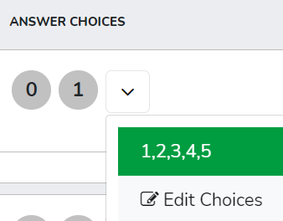
Scroll down to the Rubrics section and either choose one or scroll down to the User Created section and choose one you have already created or create a new choice. | 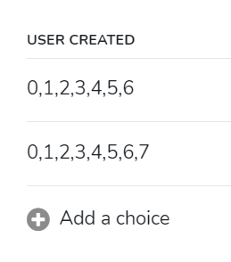
To add a choice, type in the numbers into the boxes. Click the plus sign to add a new choice. Click the checkmark when finished. | 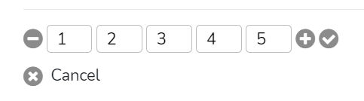
Be sure to turn on whichever choice you want. | 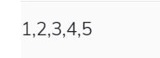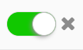
The weight defaults to 1; you can change this if you want. | 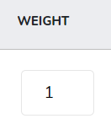
Select the standard(s) for each question.  If the standard isn’t listed, click on the Edit Standards option to add any missing standards. | 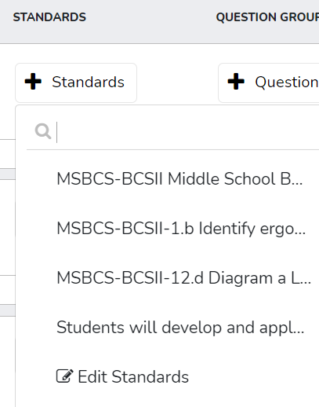
Add a question group if you want. | 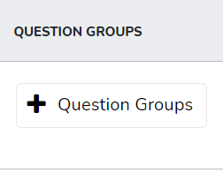
Add Extra Credit by checking the box. | 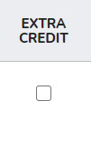
To add a copy of the assessment for students to see online, click upload materials and follow the prompts to either add from Google Drive or from your computer. | 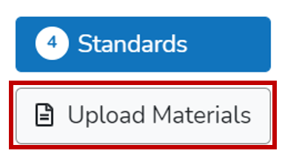
When you are finished, click on the Done button at the top right. | 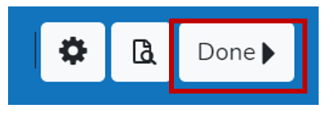
Now you are ready to set up the administration.  Click Online. | 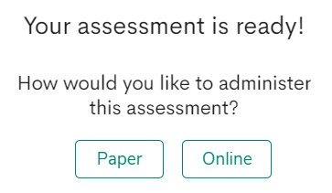
Choose either Test in Portal and assign it to yoru rosters or choose Test with Quick Code and give the code to your students.  Remember, if you do not want Illuminate to capture your students’ answers, then you do not have to give students the quick code or tell them to ignore the assessment in Illuminate. | 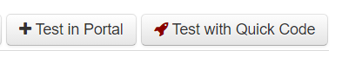

To Grade your Students’ Work

Click on the View Assessments tile or click on the Assessments button at the top right and choose View Assessment. | 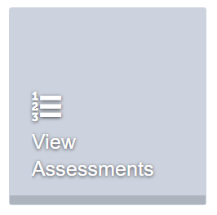
Click on the name of the assessment/rubric. | 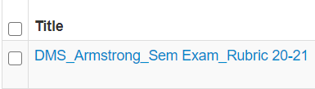
Click on the Administer button at the top right. | 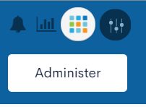
Click on Edit/Enter. | 
Choose the classes to grade and scroll down to click on Find Students. | 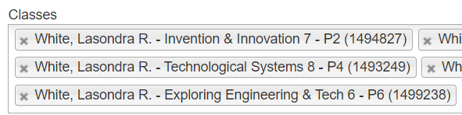  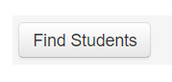
Change from Grid view to Constructed Response view. | 
Click on the By Student button. This will allow you to grade by student, versus the default of grading by question.
From the Result dropdown arrows, choose the number for the grade for each question/rubric indicator. | 